Declaration of Academic Integrity
Academic Integrity is a central tenet of Singapore Polytechnic. The polytechnic rules state that "Cheating in examinations and other assessed work is a very serious offence. This includes copying and using plagiarised material. Any student who cheats, attempts to cheat or breaches any rules for examinations and tests will face disciplinary action. The student is liable to be expelled."
Check only one of the two options below:
☐ I affirm that the work I submit is my own, produced without help from any AI tool(s) and/or other source(s).
☒ I affirm that the work I submit has been produced with the use of AI tool(s) and/or other source(s) which I have acknowledged fully in the following section.
By signing this form, I declare that the above affirmation made is true, and that I have read and understood the rules stated in Students Handbook on “Plagiarism” and “Breach of Examination/Assessment Rules”.

Name:  Bai Haotian | Student ID:  p2524290 | Class:  DCITP/FT/1A/04
Signature:  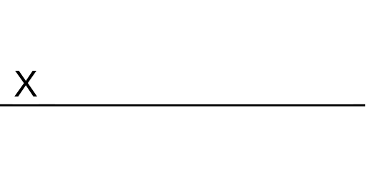 | Date:  7/29/2025

Acknowledgement of use of AI tool(s) and/or other source(s) (where applicable)

AI tool(s)
Name of AI tool | ChatGPT
Input prompt | https://chatgpt.com/share/68886cfb-8fd0-800f-9fd2-64e04fac5243  https://chatgpt.com/share/68887c6e-1a78-800f-b812-ee5eac7a1896
Date generated | 22/5/2025-29/5/2025
Output generated | The output is in the link.
Impact on submission | It helps me to obtain a large amount of information in a short time and make it into a table, so that I can make pie charts and bar charts. At the same time, it can tell me the source of the data.

Other source(s)
Source | Impact on submission
https://handyorg.github.io/handycontrol/extend_controls/ | This provide the link in my UI design.
https://www.newamerica.org/the-thread/ | This provide me with the design of my responsive navbar.
https://www.sohu.com/a/738792999_121843185  https://global.chinadaily.com.cn/a/201808/03/WS5b63975da3100d951b8c8570.html  https://china.caixin.com/2017-02-23/101058382.html  https://news.cgtn.com/news/2020-01-07/-Jack-Ma-There-is-enormous-potential-in-educational-reform-N45FT0XcZ2/index.html  https://www.facebook.com/p/Fatima-Foundation-Nepal-100081516651009/?_rdr | Picture sources.

